**Game Mechanics and Gameplay Design (CRE342) – Analysis of I Don’t give a Duck**

**Part 1A: Game Concept Critical Evaluation of Core Game Concept**

* 1) Asses the effectiveness of click-based mechanics or player engagement
* 2) Analyse the game’s potential scaling from 12 levels to 100+ levels
* 3) Identify design strengths and limitations with supporting evidence
* 4) Consider accessibility, player psychology, and technical constraints (mobile)

**1)** Click based mechanics within games can be effective at keeping players engaged through different psychological factors that go into how developers orient games towards their audience. An example of how they do this is by taking into consideration aspects such as immediate gratification theory. Immediate gratification theory is the theory that players would get instant feedback leading to sooner in game progression. This theory feeds off the player’s impulsive behaviours to give them an instant response and this can also be found within the game “I Don’t Give a Duck” throughout every level as clicking the ducks produce feedback, whether it be positive negative, or neutral, this is also the case for other games of the same genre. Figure 1, Figure 2, Figure 3 is an example of the different games within the same genre, with simple game mechanics and concepts as performing an action within those games also provide the player with an immediate response from the game. Another psychological factor is the feel of the mechanic, as it can be engaging for the player is they reach a certain ‘flow’ within the game as the simplicity of the mechanics would allow for the game to be accessible and understood by the majority of player demographic.

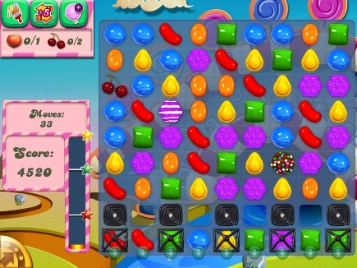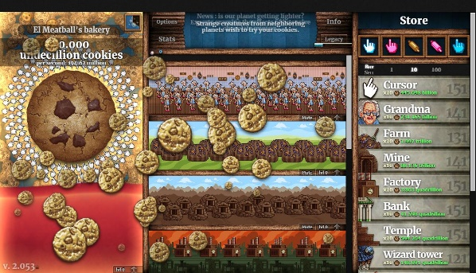

Figure : Candy Crush Saga

Figure : Fruit Ninja

Figure : Cookie Clicker

**Part 1B: Game Concept Mitigation Techniques & Enhancement Strategies**

* 1) Suggest methods to maximise variety within the 100-level constraint
* 2) Propose solutions for mechanical depth without compromising accessibility
* 3) Recommend approaches to expand thematic potential in a compact experience
* 4) Address pacing and difficulty progression issues over fewer levels

**Part 1C: Critical Evaluation of Current Gameplay**

* 1) Identify gameplay elements that distract or disengage players from the core experience
* 2) Analyse positive and engaging aspects of the current gameplay implementation
* 3) Evaluate the effectiveness of the 12-level progression structure and pacing
* 4) Assess user interface, feedback system, and overall player experience quality

**Part 1D: Gameplay Improvement Proposals**

* 1) Propose mechanical enhancements to improve core gameplay loop and payer satisfaction
* 2) Suggest audio-visual polish improvements (sound design, particle effects, animations)
* 3) Recommend UI/UX optimisations for better engagement and information clarity
* 4) Address state transformation improvements to create smoother gameplay flow and experience continuity

NOTES

* Casual Game – Generally female demographic ~
* 55-65% Female
* Short reward loops, not a lot of cognitive load, playing while they are out, free at work
* Belief that playing games with cognitive load would increase brain functionality and maintenance of cognitive load
* Younger audience, play games on mobiles, for fun, for relaxation, for satisfaction, social interaction between other players allowing to build friendships
* Thematic expansion
* Story to hook player
* Spawn points and randomising duck spawn point
* Recognizable patterns for the player to get the used to the game
* Repetitiveness can get boring for the player
* Familiarity
* Objectives for certain levels
* Sub goals that prolong engagement
* Narrative – river or ocean for the big ducks to migrate
* Seasonal rewards for the player to work towards
* Skins or cosmetics (possibly)
* Potential powerups
* Combo modifiers to enhance gameplay - Streak
* Count the variables that don’t count the good ducks, penalty system for potential exploitation
* Bonus ducks – penalty ducks
* Ducks could have characteristics, patterns, effects, movement, for players to become more familiar with them
* Adjustable timers for the accessibility – Difficulty modes
* Visual and audio impairments – how to tackle them
* Permanent unlocks to keep players invested as they have taken their time to earn said rewards
* Different species and types of ducks
* Audio and visual cues for players with impairments
* Ambient, background sounds, sounds the ducks would make, splashing effects for water, quacks
* Punishing the player to go back through levels that they have played before, a way to fix it could be adding lives or checkpoints for the player – player could stop at a checkpoint every 5 levels
* Collectibles for the players to make them feel more immersed in the game, scarcity makes an item feel more premium, they need to be shareable to add social possibilities and status
* Checkpoints make the past efforts feel rewarded, permanent rewards feel rewarding for players
* How to bounce back from resetting, casual games will have a sort of replayability, motivates the player to jump back into the game which could help them reach another sort of flow. Saves them the effort from feeling like their past achievements were for nothing